**BUL FMS TIME MANAGEMENT**

**Software Requirement Specification**

– Hanoi, December 2022 –

**Record of change**

| **Date** | **A* M, D** | **In charge** | **Change Description** |
| --- | --- | --- | --- |
| 14/12/2022 | A | HuyVQ39 | Add Introduction |
| 14/12/2022 | A | HuyVQ39 | Add System Function |
| 14/12/2022 | A | HuyVQ39 | Add Entity Relationship Diagram |
| 14/12/2022 | A | HuyVQ39 | Add Functional Requirement Login |
| 14/12/2022 | A | HuyVQ39 | Add Functional Requirement HomePage |
| 14/12/2022 | A | HuyVQ39 | Add Functional Requirement My Request |
| 14/12/2022 | A | HuyVQ39 | Add Functional Requirement Create Request |
| 14/12/2022 | A | HuyVQ39 | Add Functional Requirement Received Request List |
| 14/12/2022 | A | HuyVQ39 | Add Functional Requirement My Late And Coming Early |
| 14/12/2022 | A | HuyVQ39 | Add Functional Requirement My Abnormal Case |

*A - Added M - Modified D - Deleted

**Table of Contents**

I. Overview **4**

1. Introduction 4

2. System Functions 5

a. Screen Flow 5

b. Screen Details 5

c. User Authorization 5

d. Non-Screen Functions 6

3. Entity Relationship Diagram 6

II. Functional Requirements **7**

1. Login 7

2. Home Page 7

3. My Request 8

4. Create Request 8

5. Received Request List 9

6. My Working Time Report 10

7. My Late Coming And Early Leave 10

8. My Abnormal Case 11

# I. Overview

## 1. Introduction

This document describes the requirements for my website, which provides the service about control time and schedule for user. Types of reader this document is intended for: developers, project managers, testers, etc.

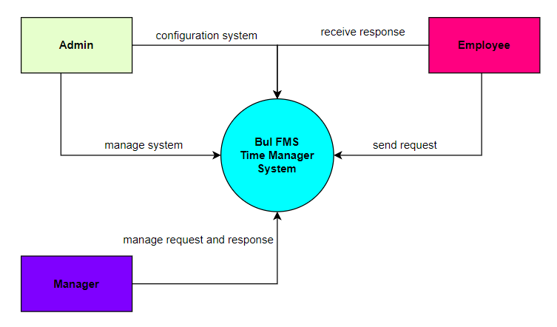

## 2. System Functions

#### a. Screen Flow

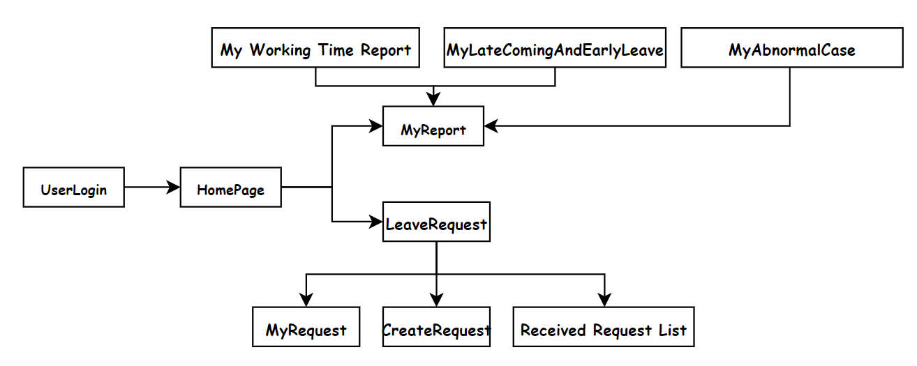

#### b. Screen Details

| **#** | **Feature** | **Screen** | **Description** |
| --- | --- | --- | --- |
| 1 | Common | Home Page | Show common information |
| 2 | Common | User Login | Allow user to login to website |
| 3 | Employee | My Working Time Report | Allow users to view their working time |
| 4 | Employee | My Late Coming And Early Leave | Allow user to view their schedule when coming and leave |
| 5 | Employee | My Abnormal Case | Allow users to view their abnormal case |
| 6 | Employee | My Request | Allow user to view their information request are approved or not |
| 7 | Employee | Create Request | Allow user to create request to web |
| 8 | Employee | Received Request List | Allow users to received list of request |

#### c. User Authorization

| **Feature** | **Admin** | **Manager** | **Employee** |
| --- | --- | --- | --- |
| Home Page | X | X | X |
| User Login | X | X | X |
| My Working Time Report |  |  | X |
| My Late Coming And Early Leave |  |  | X |
| My Abnormal Case |  |  | X |
| My Request |  |  | X |
| Create Request |  |  | X |
| Received Request List |  |  | X |

In which:

* Admin: people who manage the web
* Manager: people who manage their department employee
* Employee:people who working in company

#### d. Non-Screen Functions

| **#** | **Feature** | **System Function** | **Description** |
| --- | --- | --- | --- |
| 1 | Check Valid | All function |  |
| 2 | Check Exist | All function |  |

## 3. Entity Relationship Diagram

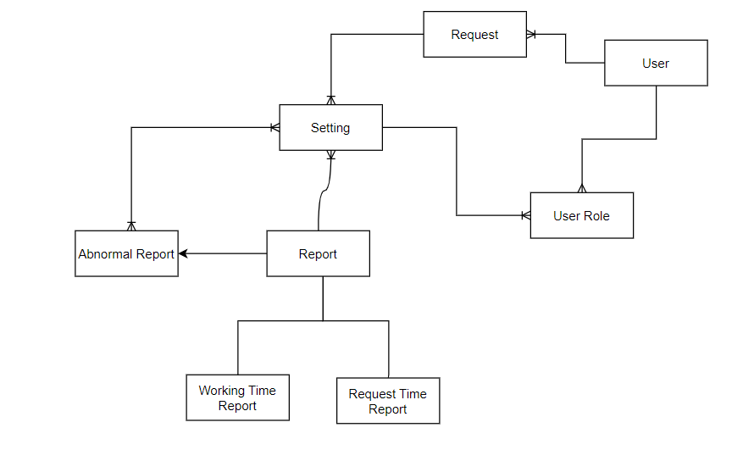

**Entities Description**

| **#** | **Entity** | **Description** |
| --- | --- | --- |
| 1 | User | Contain Basic User Information |
| 2 | User Role | Contain Role of user to filter their access require |
| 3 | Request | Contain Information from user request to web |
| 4 | Setting | Save detail module |
| 5 | Report | Contain all response for user |
| 6 | Abnormal Report | Extend part of user response |
| 7 | Working Time Report | Extend part of user response |
| 8 | Request Time Report | Extend part of user response |

# II. Functional Requirements

## 1. Login

* Function trigger: User Click on “Login” button in the Menu bar
* Function description:

Role:Common

Purpose:For people to login in the system for access to more functionality

* Screen layout: 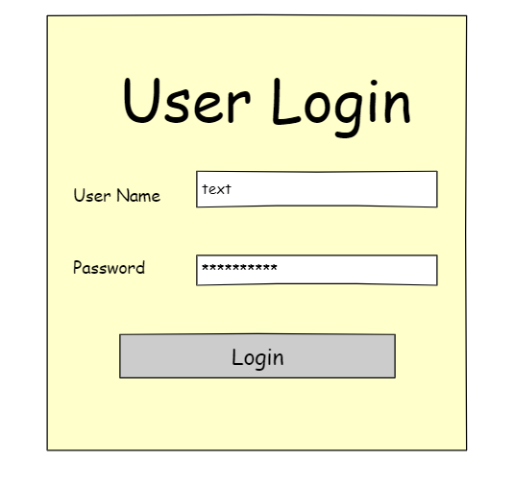

## 2. Home Page

* Function trigger: User Click on “Home Page” button in the Menu bar
* Function description:

Role:Common

Purpose:Show the static content and include web services.

* Screen layout: 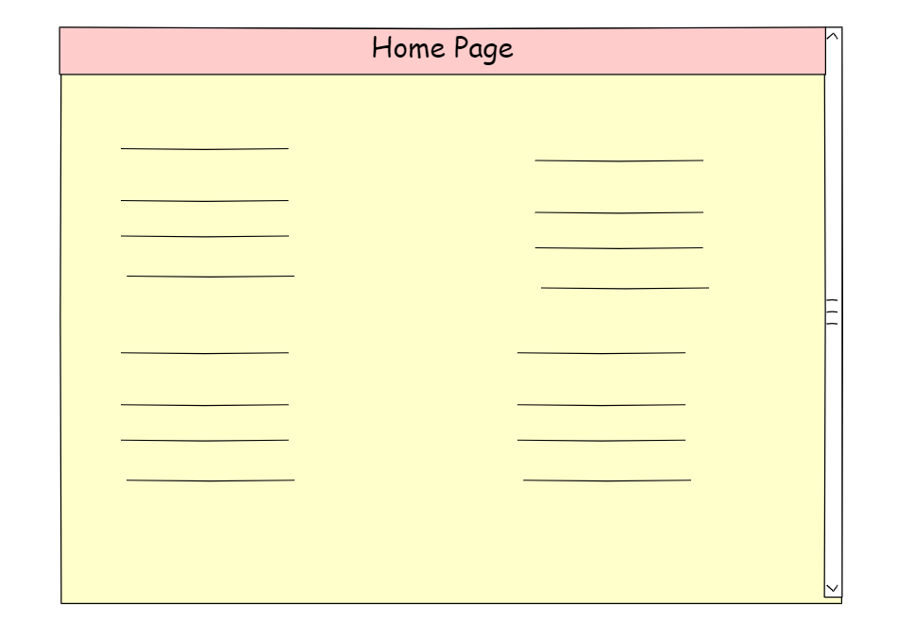

## 3. My Request

* Function trigger: Employee Click on “My Request” button in the nar bar of Leave Request
* Function description:

Role:Employee

Purpose:Show request of employee to server

* Screen layout: 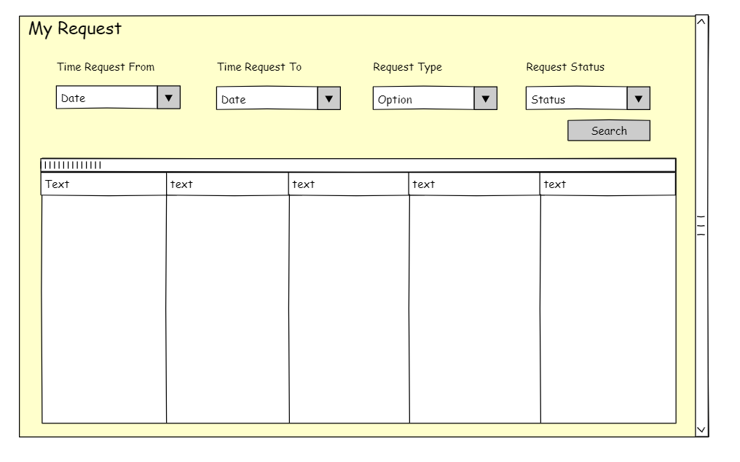

## 4. Create Request

* Function trigger: User Click on “Create Request” button in the nar bar of Leave Request
* Function description:

Role:Employee

Purpose:Allow employee to create request send to server

* Screen layout: 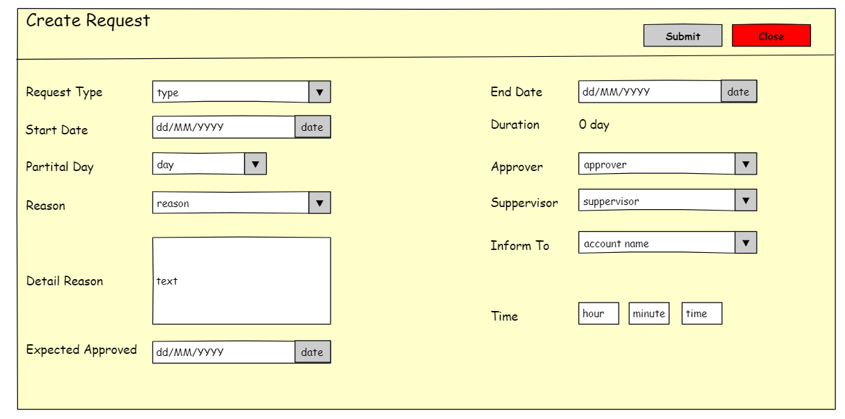

## 5. Received Request List

* Function trigger: User Click on “Received Request List” button in the nar bar of Leave Request
* Function description:

Role:Employee

Purpose:Show the list of request employee had sent

* Screen layout: 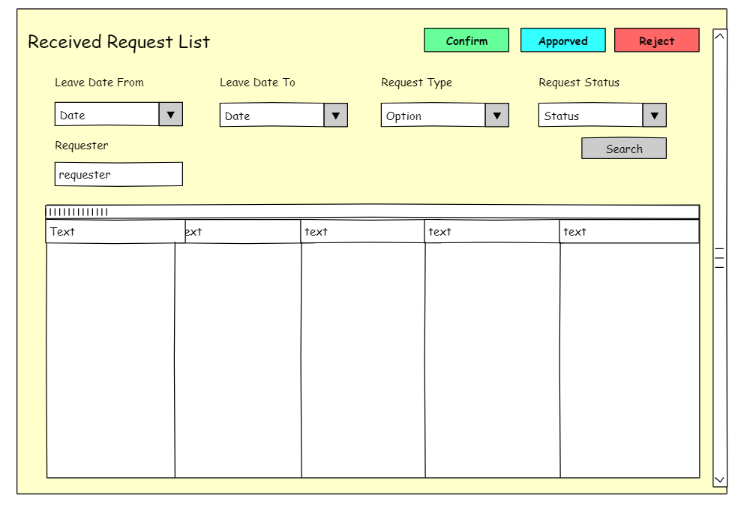

## 6. My Working Time Report

* Function trigger: User Click on “My Working Time Report” button in the nar bar of My Report
* Function description:

Role:Employee

Purpose:Show the working time of each employee

* Screen layout: 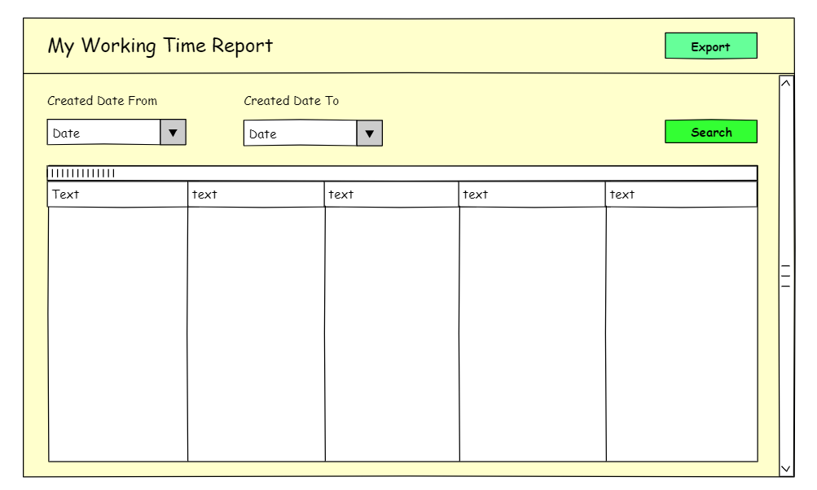

## 7. My Late Coming And Early Leave

* Function trigger: User Click on “My Late Coming And Early Leave” button in the nar bar of My Report
* Function description:

Role:Employee

Purpose:Show the late and early time of each employee

* Screen layout: 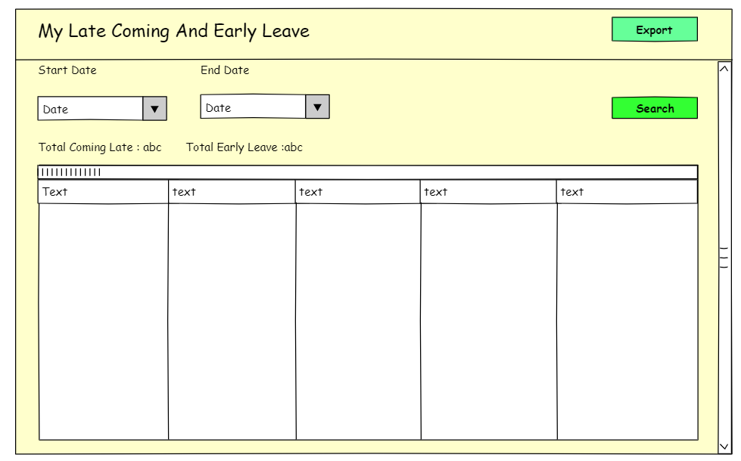

## 

## 

## 8. My Abnormal Case

* Function trigger: User Click on “My Abnormal Case” button in the nar bar of My Report
* Function description:

Role:Employee

Purpose:Show the abnormal case of each employee

* Screen layout:

